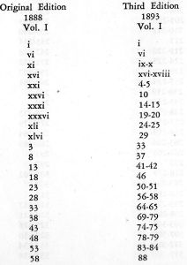 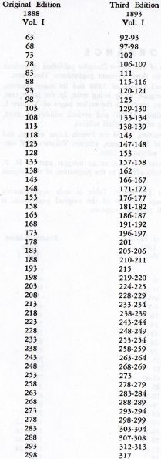 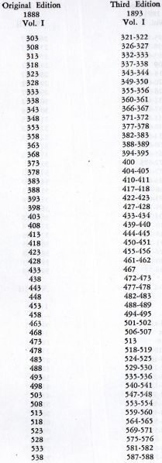 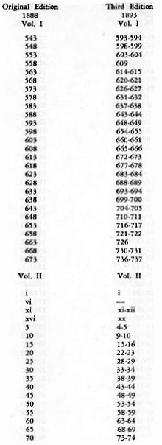

**The Secret Doctrine – Concordance**

In the many editions and reprints of *The Secret Doctrine* published by various Theosophical Organizations there are three different paginations. These are:

1. The pagination of the original edition of 1888 and its many reprints, produced either by offset of the original or by being reset. In the latter case, slight modifications of paging occur, mainly in the earlier pages of Volume 1.

2. The pagination of the so-called “Third” and revised edition of 1893, which is actually a second printing of the original edition.

3. The pagination of the 1938 edition, called the Fourth Adyar edition, and the subsequent reprints, consisting of six volumes, wherein Volumes I – IV contain Volumes I – II of the original edition of 1888.

The present edition of *The Secret Doctrine*, as an integral part of H.P. Blavatsky’s Collected Writings, strictly adheres to the pagination of the original edition of 1888. The following Concordance or Conversion Table is only approximately correct and is based on a five-page sequence of the original pagination. It should be sufficiently exact.

